Peak Performance Worksheet


PEAK ENERGY
I can work better with my natural energy patterns by…
Enter your ideas here.


PEAK ENVIRONMENT
I can improve my working environment by…
Enter your ideas here.

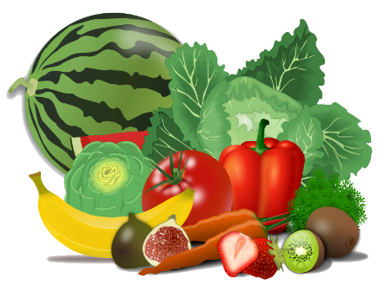
PEAK HEALTH
I can take care of my health by…
Enter your ideas here.

Ready… Set… Implement!


Pick 1 solution from each area and get started implementing them.

Get support and encouragement by posting your progress to the Savvy Grad Students Facebook Group using the hashtag #TopNotchTimeManagement



